***OUTPUT SCREEN:***

Passed TestCases:

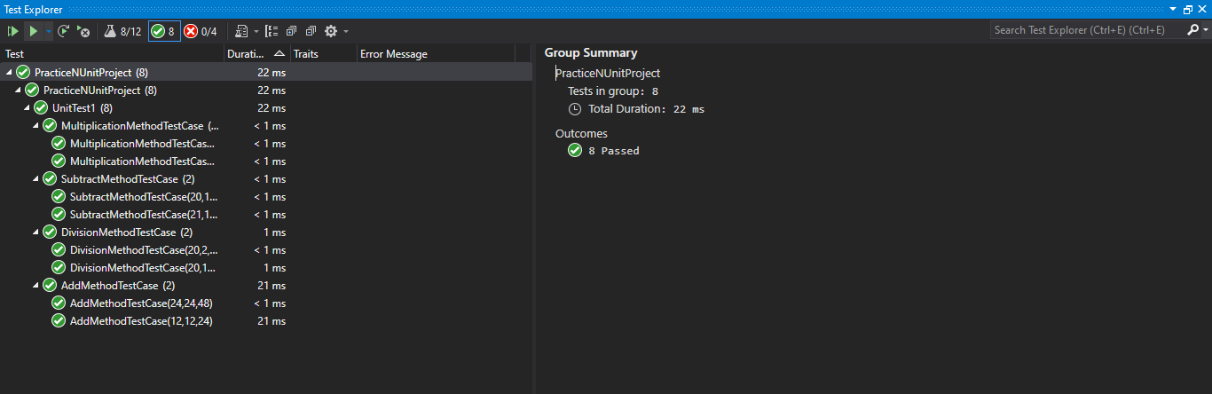

Failed TestCases:

